AMERICAN LEGION
HOMECOMING

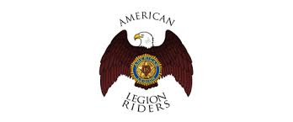
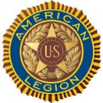
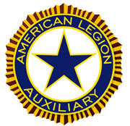
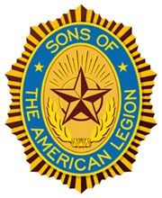
HONORING:

DAN WILEY – AMERICAN LEGION DEPARTMENT VICE COMMANDER

KAREN HASTING – DEPARTMENT AUXILIARY VICE PRESIDENT

TERRY HARRIS – SAL DETACHMENT VICE COMMANDER
LUNCHEON MENU:
Smoked Pork/Chicken Breast Sandwich
Baked Beans, Potato Salad, and Coleslaw
Cookies

October 14, 2017
(immediately following Eisenhower Pilgrimage)
12:00pm – 2:00pm
Greyhound Hall of Fame
407 S. Buckeye, Abilene, KS

$12.50 per person (RSVP by October 6, 2017)

FOR ADDITIONAL INFORMATION OR TO RSVP, CONTACT:
DEPT OF KANSAS AMERICAN LEGION (785) 232-9315
1314 SW Topeka Blvd, Topeka, KS 66612

-------------------------------------------------Please cut and mail ----------------------------------------------------------------

Name _______________________________Post/Unit/Squadron___________________________________

Guest Names_____________________________________________________________________________

Number of tickets _____________ Enclosed is my check in the amount of $______________________

