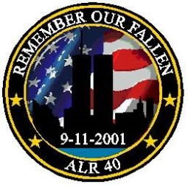
Remember Our Fallen
American Legion Riders Chapter 40 Leonardville, KS
Sunday, September 11, 2016
Registration in Leonardville at Post 40, 118 NE Erpelding.

$20.00 Registration per rider. $15.00 per Passenger. Includes Patch & Rocker.

Breakfast before the ride starting at 8:00am by donation.

Lunch in Concordia, KS at American Legion Post 76.
Registration is from 9:00am to 11:00am. Briefing at 11:15am, Kickstands up at 11:30am, running Full Flags so bring yours!
Open to all “Riders” with street legal 2, 3, and 4 wheeled vehicles.

Proceeds to Benefit Our American Legion Programs!

Leonardville to Green (Hwy 24 to Utah)
Green to Clifton thru Morganville (5 Mile Rd to Pipeline Rd)
Clifton to Concordia (Hwy 9) Lunch and fuel stop in Concordia.
Concordia to Miltonvale thru Ames (Hwy 9 to County Rd 809)
Miltonvale to Clay Center (Hwy 24)
This is around 103 miles and all blacktop as well as secondary highways.

