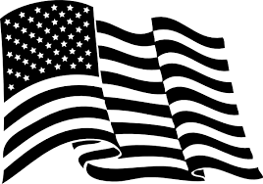
AMERICAN LEGION RIDERS CHAPTER 153 OLATHE KANSAS
is
HOSTING
The Kansas State ALR Rally
September 21-23
OLATHE Post 153
410 East Dennis Olathe Kansas, 66061-4603
Pre-registration begins 15 April-15 July 2017
Cost is $35.00 after 15 July cost is $45.00
T-shirt, patch/rocker, evening meal sat included in price along with entertainment.
Lots of vendors and a few surprises along the way.
Business meeting will commence at 1000 Sat, you must be a registered member of the ALR to participate in the meeting Presentation of your membership card will be required.
Send all registration forms and monies to the following address: ALR CHAPTER 370, ATTN: BETTY WRIGHT 7500 W. 75TH STREET, OVERLAND PARK, KS 66204-2954 (CHECKS PREFERRED PLEASE)
Annual Horse shoe tournament will also take place on Sat during the Rally.
See ALR CALENDAR FOR SCHEDULE OF EVENTS.

